Using Models to Understand Cellular Respiration

Molecules in the food you eat provide the energy that your body needs. But, your cells don’t use food molecules directly. Instead, your cells use molecules from food to provide the energy to make ATP, and ATP provides the energy for many of the processes inside your cells. For example, cells use ATP to provide the energy to synthesize a molecule or contract a muscle.
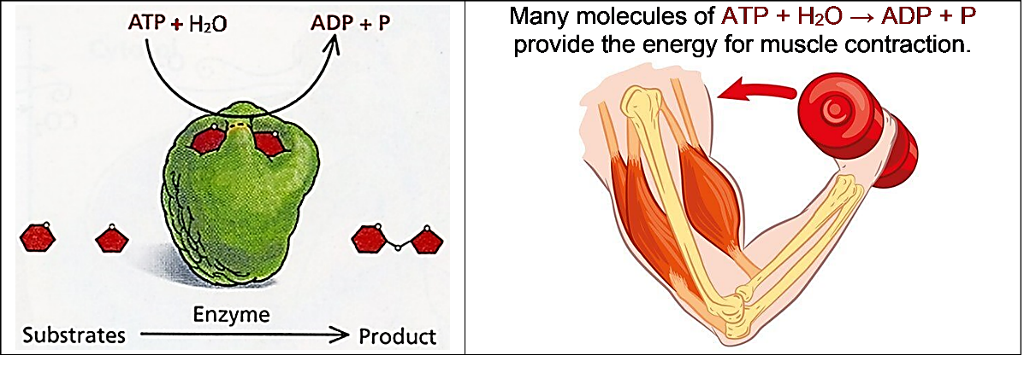

1. Inside your cells, cellular respiration uses oxygen plus molecules from food to provide the energy to make ATP. Add to the figure below to describe as much as you can about the processes that contribute to making ATP.
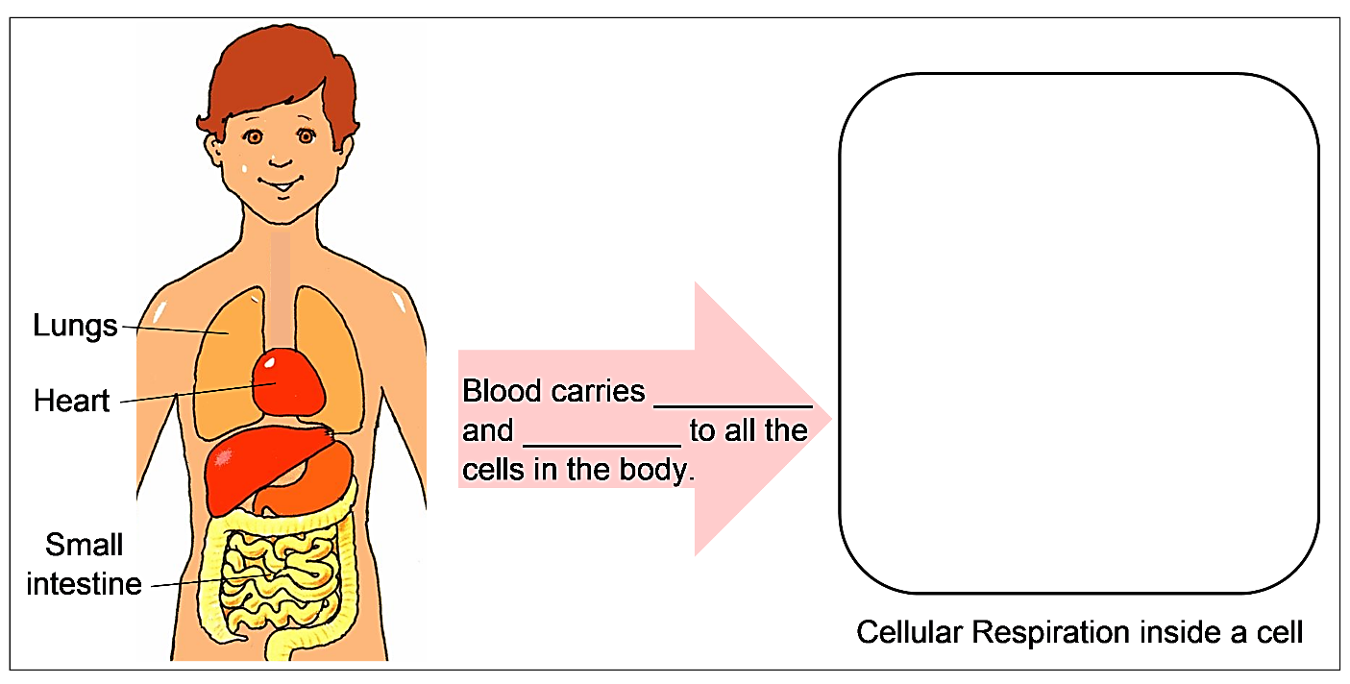

A scientific model is a simplified representation of reality that highlights some key features of a process like cellular respiration. For example, these chemical equations are a model that shows
the inputs and outputs for cellular respiration. The curved arrows represent coupled chemical reactions; the top reaction provides the energy needed for the bottom reaction.  2a. Label the molecules in the top equation. | 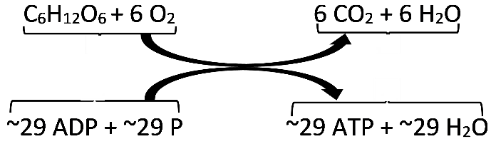

2b. Describe in words what these chemical equations tell us about cellular respiration.

The figure below presents another model of cellular respiration. It shows the three main stages of cellular respiration, which are glycolysis, the Krebs cycle, and the electron transport chain + ATP synthase. Most of the ATP is made inside an organelle, called a mitochondrion.

3a. Circle the input for cellular respiration that is shown in this figure.  3b. What output from cellular respiration is shown in this figure?  3c. Which inputs and outputs of cellular respiration are missing from this figure? (Hint: Check the chemical equations on page 1.) | 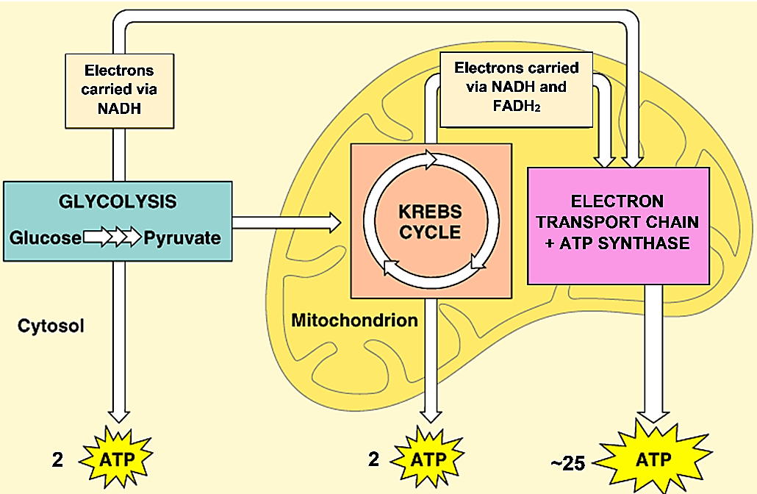

Missing inputs: | Missing outputs:

4a. Underline ATP synthase in the figure.

4b. What type of molecule do you think ATP synthase is? What do you think it does?

5. Describe each of the three main stages of cellular respiration by choosing the best matches. (Give one match per blank, and use one of the matches more than once.)

Glycolysis ___ ___
Krebs cycle ___
Electron transport chain + ATP synthase ___ ___

a. Makes most of the ATP produced by cellular respiration
b. Occurs in mitochondria (plural of mitochondrion)
c. Occurs inside cells, but not in mitochondria
d. Uses glucose as an input

6. Explain why mitochondria are often called the powerhouse of the cell.

7. What features of cellular respiration are shown in both the figure above and the chemical equations shown on page 1?

8. Different types of models have different advantages for understanding cellular respiration. Complete this table to describe the advantages of each type of model.

What are the advantages of this model for understanding cellular respiration?
The chemical equations on page 1
The figure on page 2

9. This table lists the input molecules for cellular respiration. For each input molecule, explain how our cells get this molecule or how this molecule is made inside each cell. (Hint: See figures on page 1.)
Input Molecule | How Our Cells Get this Molecule or  How this Molecule is Made Inside Each Cell
Glucose
Oxygen
ADP + P

10. Use what you have learned to construct another model of cellular respiration in the drawing of a cell with a mitochondrion. (In an actual cell there are many mitochondria.)
- Write the three main stages of cellular respiration in the appropriate blanks.
- Label each arrow with an appropriate input or output. To do this, you will need to know that the Krebs cycle produces CO₂. Also, the electron transport chain needs O₂ as an input and produces H₂O. (For simplicity, this diagram omits NADH and FADH₂.)
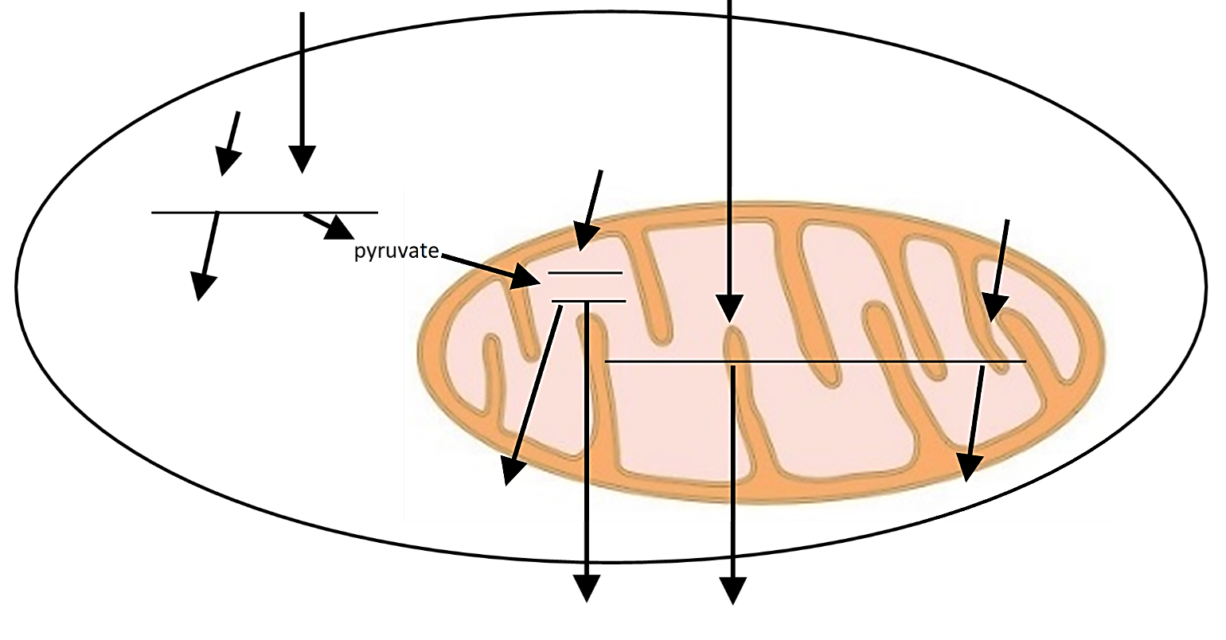

By Dr. Ingrid Waldron, Dept Biology, Univ Pennsylvania, © 2023. This Student Handout (and an advanced version) and Teacher Notes (with background information and instructional suggestions) are available at https://serendipstudio.org/exchange/bioactivities/modelCR. This activity is intended to follow "How do organisms use energy?" (https://serendipstudio.org/exchange/bioactivities/energy).

